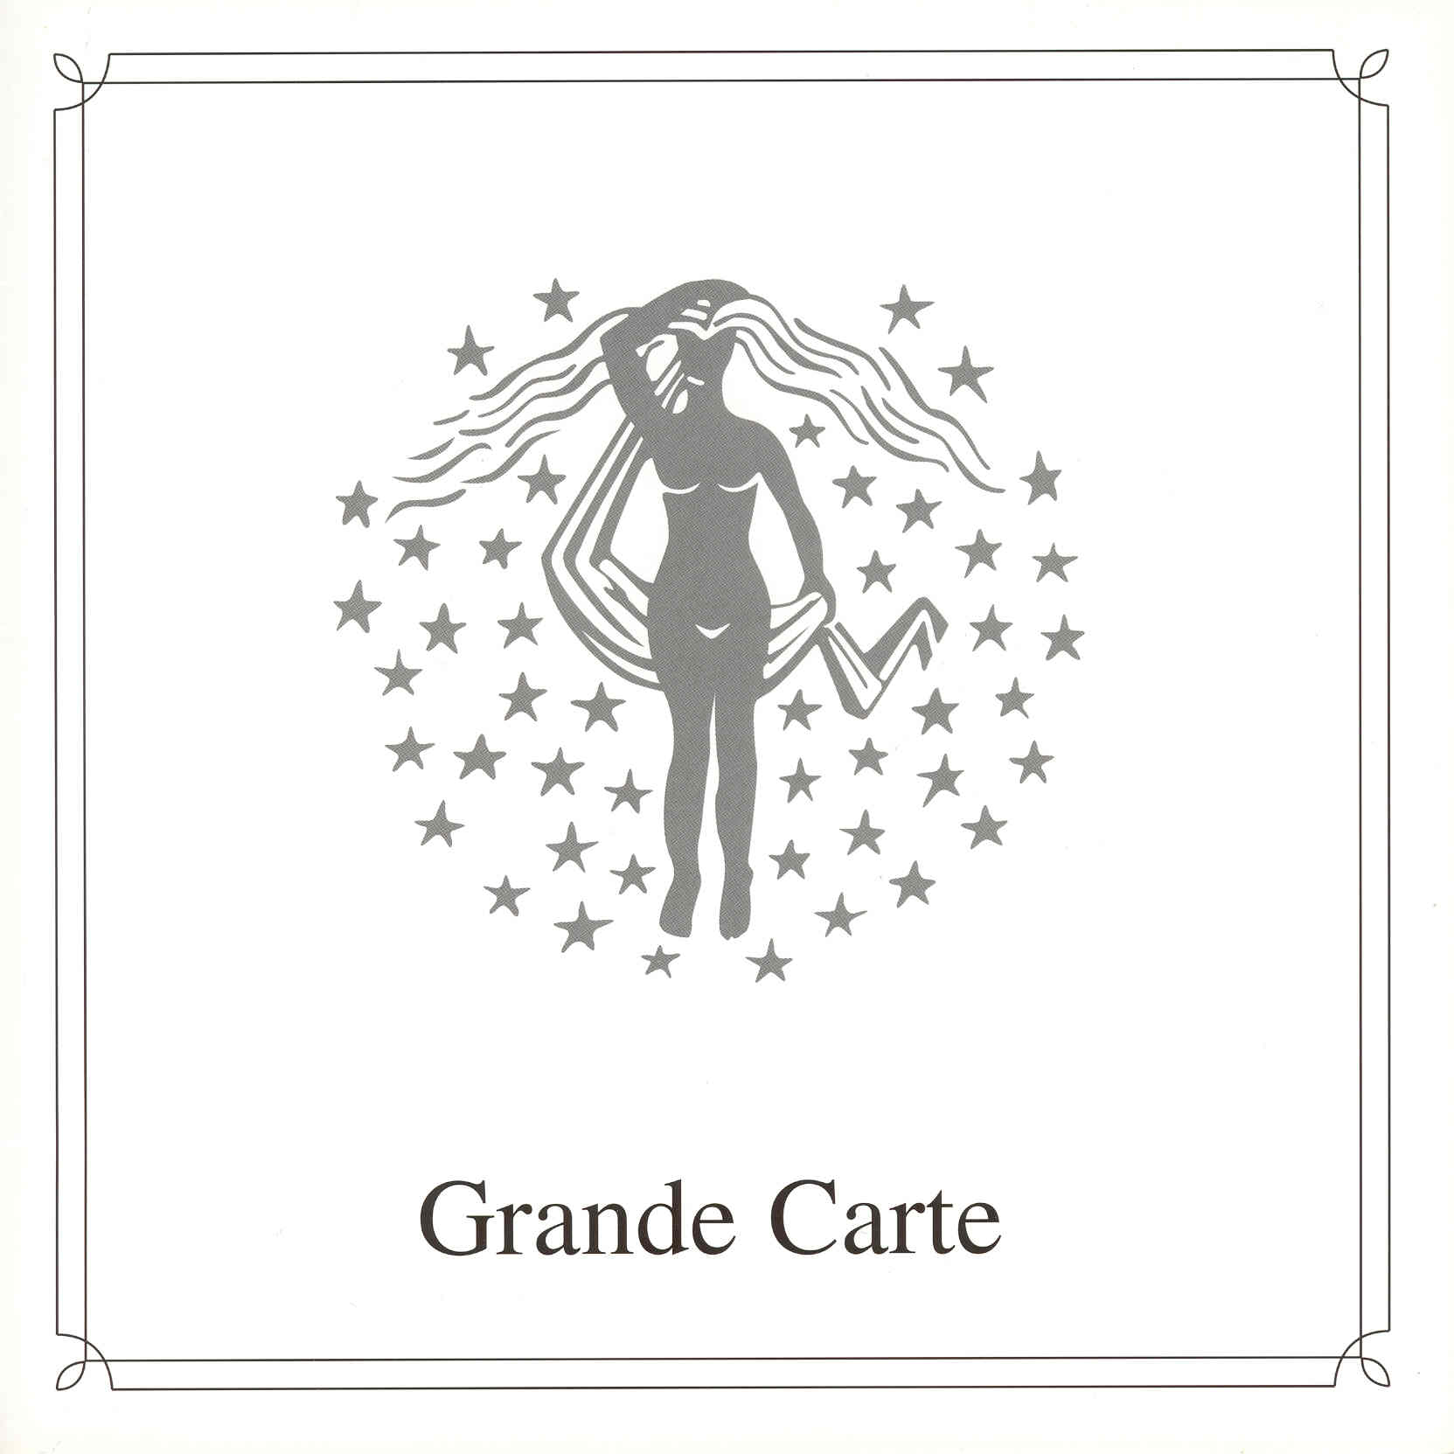

Ladies Night

CHEF’S SUGGESTIONS

Avocado and Shrimp Salad
Shrimps covered in a light mayonnaise cocktail sauce, garnished with slices of avocado and grissini
Carrot Soup V
Cream of carrot soup served with tomato concassé
Corn Fed Chicken Suprème
Served on a creamy mushroom sauce, accompanied by red cabbage,
Peas and marquis potatoes filled with tomato concassé
Chocolate Sponge Cake with Cappuccino Mousse
Sponge cake with layers of cappuccino mousse, served with apricot sauce and cherries

RECOMMENDED WINES

Moët & Chandon, NV Brut Réserve, Champagne (Available by the glass)
One of the most popular Champagnes, Superb quality and a crisp texture with good length
Woodbridge White Zinfandel (Blush/Rosé), Robert Mondavi, California
A stylish wine, loaded with strawberry fruit and subtle spicy cinnamon and nutmeg tones
Linden Estate Merlot, Hawke’s Bay, New Zealand
A full-bodied red wine with rich, ripe concentrated berry fruit

APPETISERS Melon Pearl Cocktail V
Ripe melon pearls served with melon sorbet

Avocado and Shrimp Salad
Shrimps covered in a light mayonnaise cocktail sauce,
Garnished with slices of avocado and grissini

SOUPS Carrot Soup V
Cream of carrot soup served with tomato concassé

Consommé “Princess”
Clear chicken broth with pearl barley, peas and tender chicken

Chilled Strawberry Soup V
Chilled strawberry soup flavoured with Champagne

SALAD Asparagus and Hearts of Palm Salad V
Served with crispy lettuce and a lime and lentil dressing

Orange Duck Salad
Strips of duck breast mixed with lettuce, onions, tomatoes,
Olives and orange segments. Served with a honey vinaigrette

V = Suitable for vegetarians

Some dishes may contain nuts or traces of nuts
Please contact the Maitre d’Hotel for further details

MAIN COURSES Seafood Fettuccini
Clams, prawns, crab and calamari in a tomato and pesto
Sauce served on a bed of “al dente” fettuccini

Grilled Fillet of John Dory
Grilled fillet of John Dory served on sautéed spinach, assorted
Vegetables, château potatoes and a parsley butter sauce

Fillet of Steak “Café de Paris”
Prime fillet of steak served with fennel, assorted vegetables,
jacket potatoes and Café de Paris butter

Corn Fed Chicken Suprème
Served on a creamy mushroom sauce, accompanied by red
Cabbage, peas and marquis potatoes filled with tomato concassé

Curried Mushroom Crepe V
Light herb pancake filled with curried mushrooms and
roasted pistachio nuts

Quiche Lorraine V
Served with a mixed salad and a mustard cream dressing

COLD MAIN COURSE Salmon Trio
Combination of hot smoked, marinated and tartar salmon,
Served with horseradish cream, mustard sauce and
sour cream dressing

CHEESE International Selection of Cheese
Served with grapes and biscuits

Vegetarian Cheese V
Today’s selection of vegetarian cheese

DESSERTS Chocolate Sponge Cake with Cappuccino Mousse
Sponge cake with layers of cappuccino mousse,
Served with apricot sauce and cherries

Coconut Pudding
Coconut cream pudding flavoured with Malibu, and
Garnished with tropical fruits and whipped cream

Pear Belle Hélène
Poached pear served with dairy vanilla ice cream, chocolate
Sauce and whipped cream (Also available for diabetics)

Petit Fours
From our Pastry Chef, assorted home-made petit fours

Today’s Selection of Ice Cream and Sorbet
Vanilla, maple walnut or banana ice cream
Mango or pink grapefruit sorbet

Diabetic and Soya Ice Cream
Today’s selection of diabetic and soya ice cream

V = Suitable for vegetarians

Some dishes may contain nuts or traces of nuts
Please contact the Maitre d’Hotel for further details



